TECHPRO SOLUTIONS
TEAM ID-NM2023TMID24655 TEAM LEADER NAME : VIDHYA DHARANI.B.S
INTRODUCTION:
- Project Name: Start by clearly stating the name of your project, which is "TechPro Solutions."
- Purpose: Explain the purpose or goal of your project. What problem does it aim to solve, or what value does it provide?
- Scope: Describe the scope of your project. What products or services does it encompass? Who is the target audience?
- Key Features: Highlight the key features or components that make your project unique or valuable.
- Benefits: Discuss the benefits that your project offers to users, clients, or the community at large.
- Team: If there's a team involved, introduce the key team members and their roles.
- Timeline: Provide a general timeline or milestones for the project, if applicable.
- Future Plans: Mention any future plans or developments you have in mind for TechPro Solutions.
Here's an example introduction:
Introduction to TechPro Solutions:
TechPro Solutions is an innovative project designed to address the evolving technology needs of our rapidly changing world. Our goal is to provide cutting-edge solutions for businesses, individuals, and organizations seeking to harness the power of technology to achieve their goals.
Our project encompasses a range of services, from software development and IT consulting to custom hardware solutions. We are committed to delivering efficiency, reliability, and tailored solutions to our clients, helping them stay ahead in today's dynamic tech landscape.
With a dedicated team of experts in various tech domains, TechPro Solutions is well-equipped to deliver the highest quality of services. We are driven by a vision to empower businesses with the tools they need to thrive in the digital age.
As we embark on this journey, we invite you to join us in exploring the endless possibilities that technology offers. We have an exciting roadmap ahead, with plans for expansion, partnerships, and new products to further enhance our offerings.
Feel free to adapt this template to suit the specifics of your project, and make sure to include any unique or distinguishing aspects of TechPro Solutions.

PURPOSE:
The purpose of the project "TechPro Solutions" will depend on the specific goals and objectives you've set for it. Here are some common purposes that technology-related projects like TechPro Solutions might aim to achieve:
- Technology Solutions Provider: To serve as a one-stop solution provider for businesses and individuals seeking technology-related services, such as software development, IT consulting, hardware solutions, or other tech services.
- Problem Solving: To address specific challenges or problems faced by clients or users in the tech domain and provide effective solutions to those issues.
- Innovation: To foster innovation in technology by developing new products, services, or approaches that push the boundaries of what's currently possible.
- Efficiency Improvement: To help businesses and organizations improve their operational efficiency and productivity through the adoption of technology.
- Competitive Advantage: To give clients a competitive advantage by leveraging the latest technological advancements and best practices.
- Client Empowerment: To empower clients with the knowledge and tools they need to make informed decisions and successfully implement technology in their operations.
- Adaptation to Technological Trends: To help clients stay current with the ever-evolving tech landscape, ensuring they remain relevant and competitive.
- Market Expansion: To tap into the growing technology market by offering services or products that meet the demands of this sector.
- Community Impact: To make a positive impact on the local or global community by addressing social or environmental challenges through technology.
- Financial Growth: To achieve financial success by providing valuable tech solutions and building a sustainable and profitable business.

PROBLEMS DEFINITION AND DESIGN TINIKING:
An Empathy Map is a powerful tool used in the design thinking process to gain a deeper understanding of the feelings, needs, and perspectives of your target audience or users. It helps you empathize with their experiences, which, in turn, can inform better problem definition and solution design. Here's how to create and use an Empathy Map:
1. Create the Empathy Map:
An Empathy Map typically consists of four quadrants:
- Says: What are the things your users say out loud? These are their explicit statements, opinions, and quotes related to the problem you're trying to solve.
- Thinks: What might your users be thinking but not necessarily expressing verbally? These are their inner thoughts, fears, and concerns.
- Feels: What are the emotions and feelings your users are experiencing related to the problem? Are they frustrated, excited, worried, or confident?
- Does: What actions or behaviors are your users engaged in when dealing with the problem? What steps do they take, or what do they do in their current situation?
2. Gather Information:
To fill in each quadrant of the Empathy Map, gather information through various means, such as:
- User interviews: Conduct one-on-one interviews with your target users to ask them about their experiences and feelings regarding the problem you're addressing.
- Surveys: Collect data from surveys to identify common statements and sentiments related to the problem.
- Observation: Observe user behavior in the context of the problem you're solving. This could include observing their actions, body language, and interactions.
3. Fill in the Map:
Place the information you gather in the appropriate quadrant of the Empathy Map. Use keywords, phrases, or even visual representations to convey the thoughts, feelings, statements, and actions of your users.
4. Analyze and Synthesize:
Once you've filled in the Empathy Map, step back and look for patterns and insights. What are the common themes and emotions that emerge from the map? What needs and pain points do users express? This analysis will help you better understand the user experience related to the problem.
5. Use in Problem Definition and Solution Design:
The insights from the Empathy Map can inform both problem definition and solution design:
- Problem Definition: The map helps you define the problem more precisely by highlighting the emotional and cognitive aspects of the user experience. It ensures that you're addressing the actual needs and concerns of your users.
- Solution Design: The map provides a solid foundation for ideation and design. By understanding what your users think, feel, say, and do, you can create solutions that cater to their emotional and practical needs.

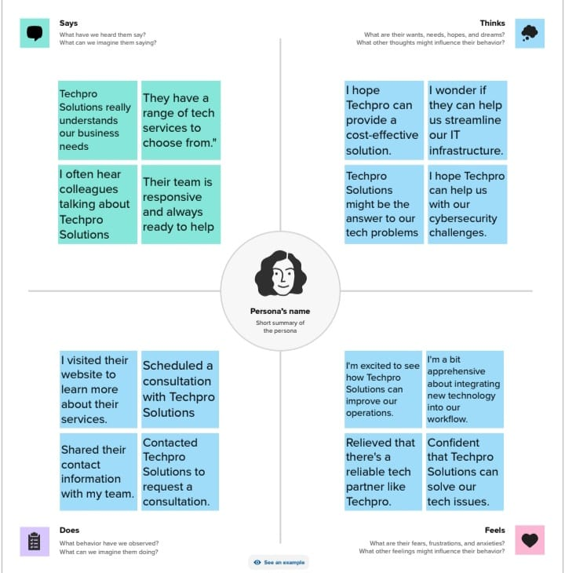
IDEATION AND BRAINSTROMING MAP:
1. Central Idea or Problem:
- Start with a central idea or problem statement at the center of the map. This is the focus of your brainstorming session.
2. Main Branches:
- Create main branches radiating out from the central idea. These branches represent high-level categories or themes related to the problem.
3. Sub-branches:
- For each main branch, create sub-branches to explore specific ideas or solutions. You can create as many sub-branches as needed for each main category.
4. Nodes and Keywords:
- At the end of each sub-branch, place nodes or keywords that represent individual ideas or concepts. These can be single words or short phrases.
5. Visual Connections:
- Connect related nodes or branches with lines or arrows to show how ideas are connected or build upon each other.
6. Color and Visual Elements:
- You can use colors, icons, or other visual elements to highlight key ideas, categorize concepts, or indicate priorities.
7. Collaborative Tools:
- If you're brainstorming with a team, consider using online collaborative tools like Miro, Lucidspark, MindMeister, or similar applications to create a digital brainstorming map that allows team members to contribute and interact in real-time.
8. Iteration and Refinement:
- Remember that brainstorming maps are dynamic and can evolve as ideas flow. It's okay to add, reorganize, or refine elements as the brainstorming session progresses.

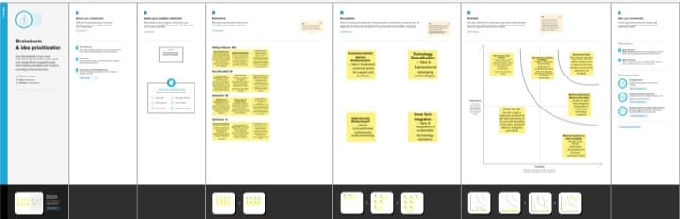
RESULT:
FINALFINDINGS (OUTPUT) OF THE PROJECT:
- Problem Analysis and Definition: Summarize the problems you identified and defined at the beginning of the project. This should provide a clear understanding of the issues you set out to address.
- Research and Data: Present any research findings, data, or insights gathered throughout the project. This can include market research, user surveys, feedback, and any other relevant information that informed your project.
- Solutions and Innovations: Describe the solutions, innovations, or products developed as part of the project. Highlight how these solutions address the identified problems and their unique features.
- User Feedback: Share feedback from users or clients who interacted with the project's solutions. Include testimonials or case studies if applicable to showcase the impact on users.
- Impact and Outcomes: Provide an analysis of the impact of your project. This could include improved efficiency, cost savings, increased revenue, or any other measurable outcomes.
- Challenges and Lessons Learned: Reflect on any challenges encountered during the project and the lessons learned from them. Discuss how these challenges were overcome or mitigated.
- Future Plans and Recommendations: Offer insights into future plans for the project, including potential expansion, partnerships, or new features. Provide recommendations for further development.
- Team Contributions: Acknowledge the contributions of team members, partners, or stakeholders who played a significant role in the project's success.
- Visuals and Demonstrations: Use visuals such as charts, graphs, diagrams, or even live demonstrations to illustrate key points, especially when presenting to stakeholders or a broader audience.
- Concluding Remarks: Conclude with a summary of the project's achievements, the value it has delivered, and its overall success in meeting its objectives.
PROFIT AND LOSS A/C AND BALANCA SHEET A/C ABOVE:
ADVANTAGES AND DISADVANTAGES :
ADVANTAGES:
- Technology Expertise: TechPro Solutions can provide access to a team of skilled professionals with expertise in various technology domains, including software development, IT consulting, and hardware solutions.
- Efficiency Improvement: Clients and businesses that utilize TechPro Solutions may experience improved operational efficiency through the implementation of technology solutions, leading to cost savings and productivity gains.
- Customized Solutions: TechPro Solutions may offer tailored and customized technology solutions to meet the unique needs and requirements of clients, ensuring that the solutions align with their specific goals.
- Competitive Advantage: Businesses that partner with TechPro Solutions can gain a competitive edge by staying up-to-date with the latest technological advancements and best practices.
- Cost Savings: Efficient technology solutions can lead to cost savings by streamlining processes and reducing manual work, ultimately impacting the bottom line positively.
- Innovation: TechPro Solutions may drive innovation by creating new products, services, or approaches that solve problems or address market needs more effectively.
- Technical Support: Clients can benefit from ongoing technical support and maintenance services, ensuring that their technology solutions remain reliable and up-to-date.
- Scalability: TechPro Solutions can help clients scale their technology infrastructure as their business grows, providing the flexibility to adapt to changing needs.
- Risk Mitigation: Effective technology solutions can help mitigate risks associated with data security, compliance, and other technology-related challenges.
- Knowledge Transfer: TechPro Solutions may offer training and knowledge transfer to empower clients to better understand and manage their technology solutions.
- Customer Satisfaction: Improved technology and efficiency can enhance the customer experience, leading to increased customer satisfaction and loyalty.
- Streamlined Communication: TechPro Solutions may facilitate better communication and collaboration within organizations through the integration of communication and collaboration tools.
- Market Expansion: By providing high-quality technology services, TechPro Solutions can expand its market reach and gain new clients.
- Informed Decision-Making: Data analytics and business intelligence services offered by TechPro Solutions can help clients make data-driven decisions.
- Sustainability: TechPro Solutions may promote sustainable and eco-friendly technology solutions, which can benefit both clients and the environment.

DISADVANTAGES:
- Competition: The technology industry is highly competitive, with many established players and new startups. Competing effectively can be challenging.
- Rapid Technological Changes: Keeping up with the fast pace of technological advancements requires constant learning and adaptation, which can be resource-intensive.
- Security Risks: Dealing with sensitive client data and technology infrastructure exposes TechPro Solutions to potential security vulnerabilities and data breaches.
- Client Dependency: Over-reliance on a small number of major clients can create vulnerability if those clients reduce or terminate their contracts.
- Resource Intensity: Developing and maintaining technology solutions can be resource-intensive, requiring significant investments in talent, infrastructure, and ongoing support.
- Market Saturation: In certain technology sectors, the market may be saturated with service providers, making it difficult to stand out.
- Regulatory Challenges: Staying compliant with changing technology and data protection regulations can be complex and expensive.
- Staff Turnover: Attracting and retaining skilled technology professionals can be challenging in a competitive job market.
- Client Resistance to Change: Some clients may be resistant to change or hesitant to adopt new technology, making it harder to implement solutions.
- Ethical Considerations: The project may face ethical dilemmas, such as decisions related to data privacy, AI ethics, or other technology-related ethical issues.
- Project Delays: Complex technology projects can face delays due to unforeseen technical challenges, scope changes, or resource constraints.
- Cost Overruns: Initial project budgets can be exceeded due to unforeseen expenses or scope changes.
- Quality Assurance: Ensuring the quality and reliability of technology solutions can be a constant challenge.
- Technological Obsolescence: Solutions developed may become obsolete in a rapidly changing tech landscape, necessitating regular updates.
- Client Expectations: Meeting or exceeding client expectations can be demanding, especially when clients have high expectations for technology solutions.

APPLICATIONS:
- Software Development: TechPro Solutions can develop custom software applications for businesses, which may include mobile apps, web platforms, e-commerce solutions, and more.
- IT Consulting: Providing consultancy services to organizations on IT strategies, infrastructure optimization, and technology adoption.
- Hardware Solutions: Designing, developing, or consulting on hardware solutions, such as IoT devices, sensors, and hardware components.
- Data Analytics: Offering data analysis and business intelligence services to help businesses make data-driven decisions.
- Cybersecurity: Assisting clients with cybersecurity solutions to protect their data and infrastructure from threats and breaches.
- Cloud Computing: Helping businesses migrate to and optimize their operations in the cloud, including cloud hosting, storage, and services.
- Web Development: Creating and maintaining websites and web applications for businesses or individuals.
- Mobile App Development: Developing mobile applications for various platforms, including iOS and Android.
- AI and Machine Learning: Implementing artificial intelligence and machine learning solutions to automate processes, make predictions, and enhance user experiences.
- Tech Support and Maintenance: Providing ongoing technical support, troubleshooting, and maintenance services for technology solutions.
- E-commerce Solutions: Developing and optimizing e-commerce platforms for online businesses.
- Software Testing: Ensuring the quality and functionality of software through rigorous testing and quality assurance processes.
- Blockchain Technology: Implementing blockchain solutions for industries that require secure and transparent transaction records.
- Internet of Things (IoT): Designing and developing IoT solutions for businesses looking to connect and monitor devices and data.
- Healthcare Technology: Creating software or hardware solutions for healthcare providers or medical technology companies.
- Education Technology: Developing e-learning platforms, educational apps, or digital educational content.
- Financial Technology (Fintech): Providing technology solutions for financial services, such as payment processing, mobile banking, and cryptocurrency.
- Environmental and Sustainability Technology: Creating technology solutions that promote environmental sustainability and eco-friendly practices.
- Smart Cities: Developing technology for urban planning and management, including smart infrastructure, transportation, and public services.
- Agriculture Technology (Agtech): Designing solutions that improve agricultural processes and productivity, such as precision farming and data analytics for farmers.

CONCLUTION:
Conclusion - TechPro Solutions: Bridging the Gap Between Vision and Innovation
As we bring our project, TechPro Solutions, to a close, it's an opportune moment to reflect on the journey we've embarked upon. What began as a vision has transformed into a dynamic reality, uniting technology, expertise, and innovation to empower our clients and foster a world of possibilities.
Throughout this project, we've harnessed the immense potential of technology to address a myriad of challenges, from software development to IT consulting, and beyond. We've navigated the ever-evolving landscape of technology, embracing change as an opportunity rather than an obstacle.
Our mission to provide custom solutions has led us to create not just software but experiences, not just consultations but transformations, and not just hardware but progress. We've witnessed businesses grow, adapt, and thrive in a tech-driven world, and in doing so, we've celebrated our own growth as a project.
In conclusion, TechPro Solutions is more than just a project. It's a testament to the power of technology as an enabler of progress, a catalyst for change, and a bridge between aspiration and reality. As we look ahead, our journey continues as we explore new frontiers, break down boundaries, and amplify the impact of technology.
We extend our heartfelt gratitude to our team, our clients, and all those who have been part of this remarkable journey. Together, we've taken a step forward in the world of technology, and we're excited for what the future holds.
TechPro Solutions is not just a conclusion; it's a continuation, a promise of more to come, and an invitation to innovate, inspire, and make a difference. Thank you for being part of our journey.
FUTURE SCOPE :

- Expansion of Service Offerings: Consider diversifying your services to encompass emerging technology trends. This may include services related to artificial intelligence, blockchain, augmented reality, virtual reality, or other innovative domains.
- Industry-Specific Solutions: Tailor your solutions to specific industries such as healthcare, finance, education, or manufacturing. Specializing in niche markets can lead to valuable partnerships and clients.
- Global Reach: Explore opportunities to expand your project's reach beyond local or regional boundaries. The global market offers immense potential for growth.
- Sustainability and Green Tech: As environmental concerns rise, there's a growing demand for technology solutions that promote sustainability. Develop eco-friendly and energy-efficient tech services.
- Partnerships and Collaborations: Collaborate with tech startups, research institutions, or industry leaders to stay at the forefront of technology advancements and expand your project's capabilities.
- User-Centered Design: Focus on enhancing user experiences by investing in user-centered design and usability testing. A user-centric approach can set you apart from competitors.
- Data Security and Privacy: Stay updated with the latest cybersecurity trends and offer robust data security and privacy solutions to safeguard clients' information.
- Artificial Intelligence and Automation: Explore AI-driven solutions that automate tasks, improve data analysis, and enhance decision-making processes.
- Digital Transformation: Help businesses undergo digital transformations by assisting with cloud migration, software modernization, and digital strategy development.
- Education and Training: Develop educational programs and training resources to empower clients and the wider community with tech skills and knowledge.
- Community Engagement: Foster a strong online community around your project, providing a platform for discussions, collaboration, and shared learning experiences.
- Innovation Hubs: Consider establishing innovation hubs or research centers to explore cutting-edge technologies and develop groundbreaking solutions.
- Smart City Initiatives: Engage with smart city projects to create tech solutions for urban development, transportation, and public services.
- E-commerce Ecosystem: Develop a comprehensive e-commerce ecosystem, supporting businesses in online sales, digital marketing, and customer engagement.
- Customization and Personalization: Offer highly customized solutions that adapt to the unique needs of each client.

